Warm up Exercise
ACTIVATE VOCABULARY. HOW GOOD IS YOUR MEMORY?

south
Antarctica
island
country
north
Pacific
America
Atlantic
sea
Europe
continent
ocean
river
coast
mountain
Asia
Oceania
geography – quiz
CHOOSE THE BEST ANSWER:
- Where is Mount Everest?
- in North America
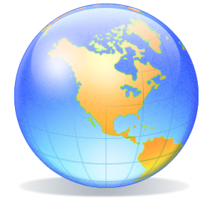
- in the Himalayas
- in the Alps

- Where is Rio de Janeiro?
- in Argentina
- in Brazil
- in Mexico

- What is the capital of the USA?
- Los Angeles
- New York
- Washington, D.C.

- Where is Japan?
- in the Indian Ocean
- in the Pacific Ocean
- in the Atlantic Ocean

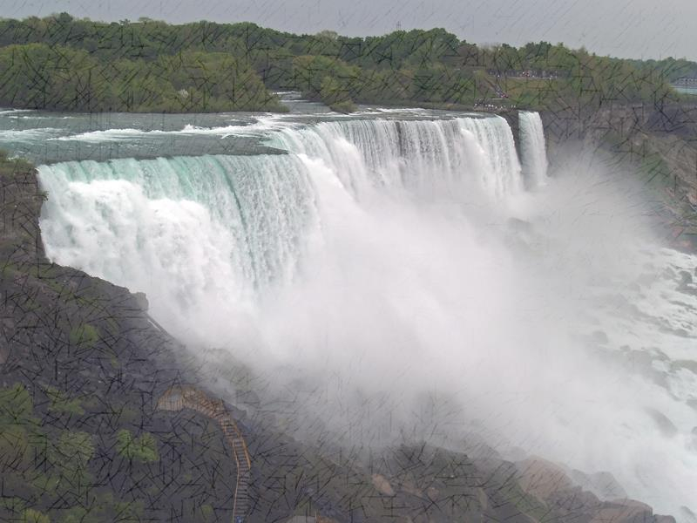
- Where are the Niagara Falls?
- Canada
- Germany
- Peru

- What is Madagascar?
- a mountain
- a desert
- an island

- Where are the Rocky Mountains ?
- North America
- South America
- Australia

- What is the capital of Ireland?
- Belfast
- Dublin
- Edinburgh

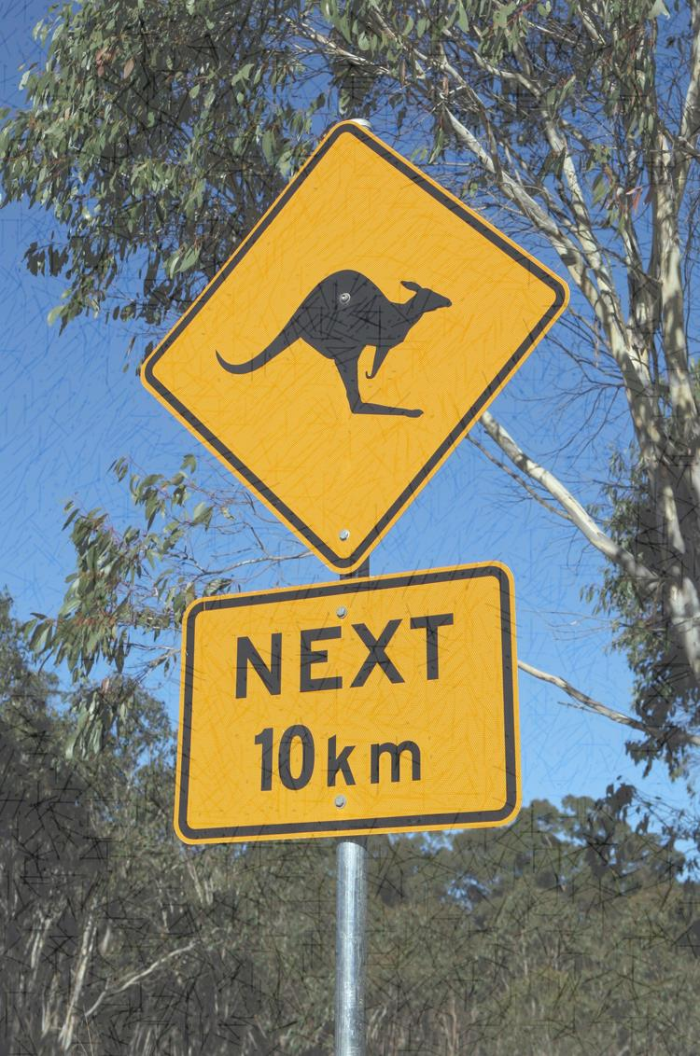
- Where is Tasmania?
- in Oceania
- in South America
- in Africa

- Where is the River Mississippi?
- in Oceania
- in South America
- in North America

- Where is the Sahara Desert?
- in Asia
- in Africa
- in Europe

- What is the capital of Australia?
- Melbourne
- Brisbane
- Canberra

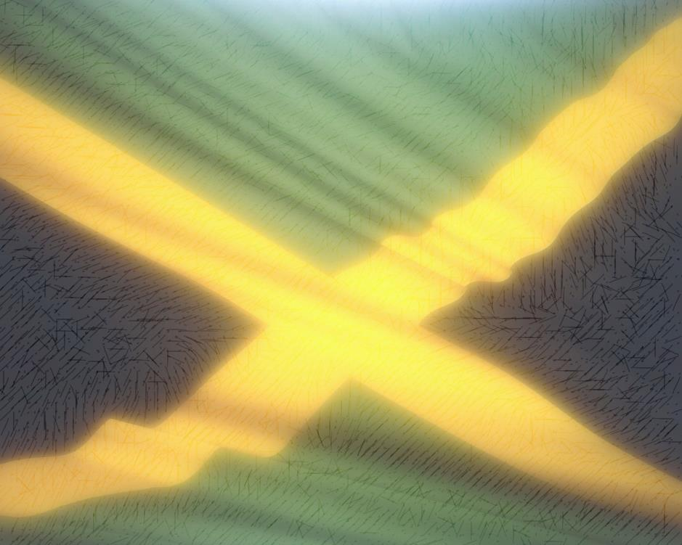

- Where is Jamaica?
- in the Atlantic Ocean
- in the Pacific Ocean
- in the Indian Ocean

- What is the Amazon?
- a mountain
- an island
- a river

- What is the capital of China?
- Tokyo
- Moscow
- Beijing

